HABITS OF A MULTIPLYING DISCIPLE: GOD’S HEART

THE VISION FOR THIS TRAINING
Our goal is that you grow in making disciples…
- Receiving fresh faith to do the impossible
- Capturing God’s heart of compassion for the world
- Following Christ in making multiplying disciples
- Joining with others (or gathering a team) to see Gospel saturation

WHAT IS GOD’S HEART FOR THE WORLD?
Read Luke 15:20-24.
- What do you observe about the Father?
- What does this story tell you about God’s heart?
There are many other passages that tell of God’s great compassion for the lost. What are some of them?

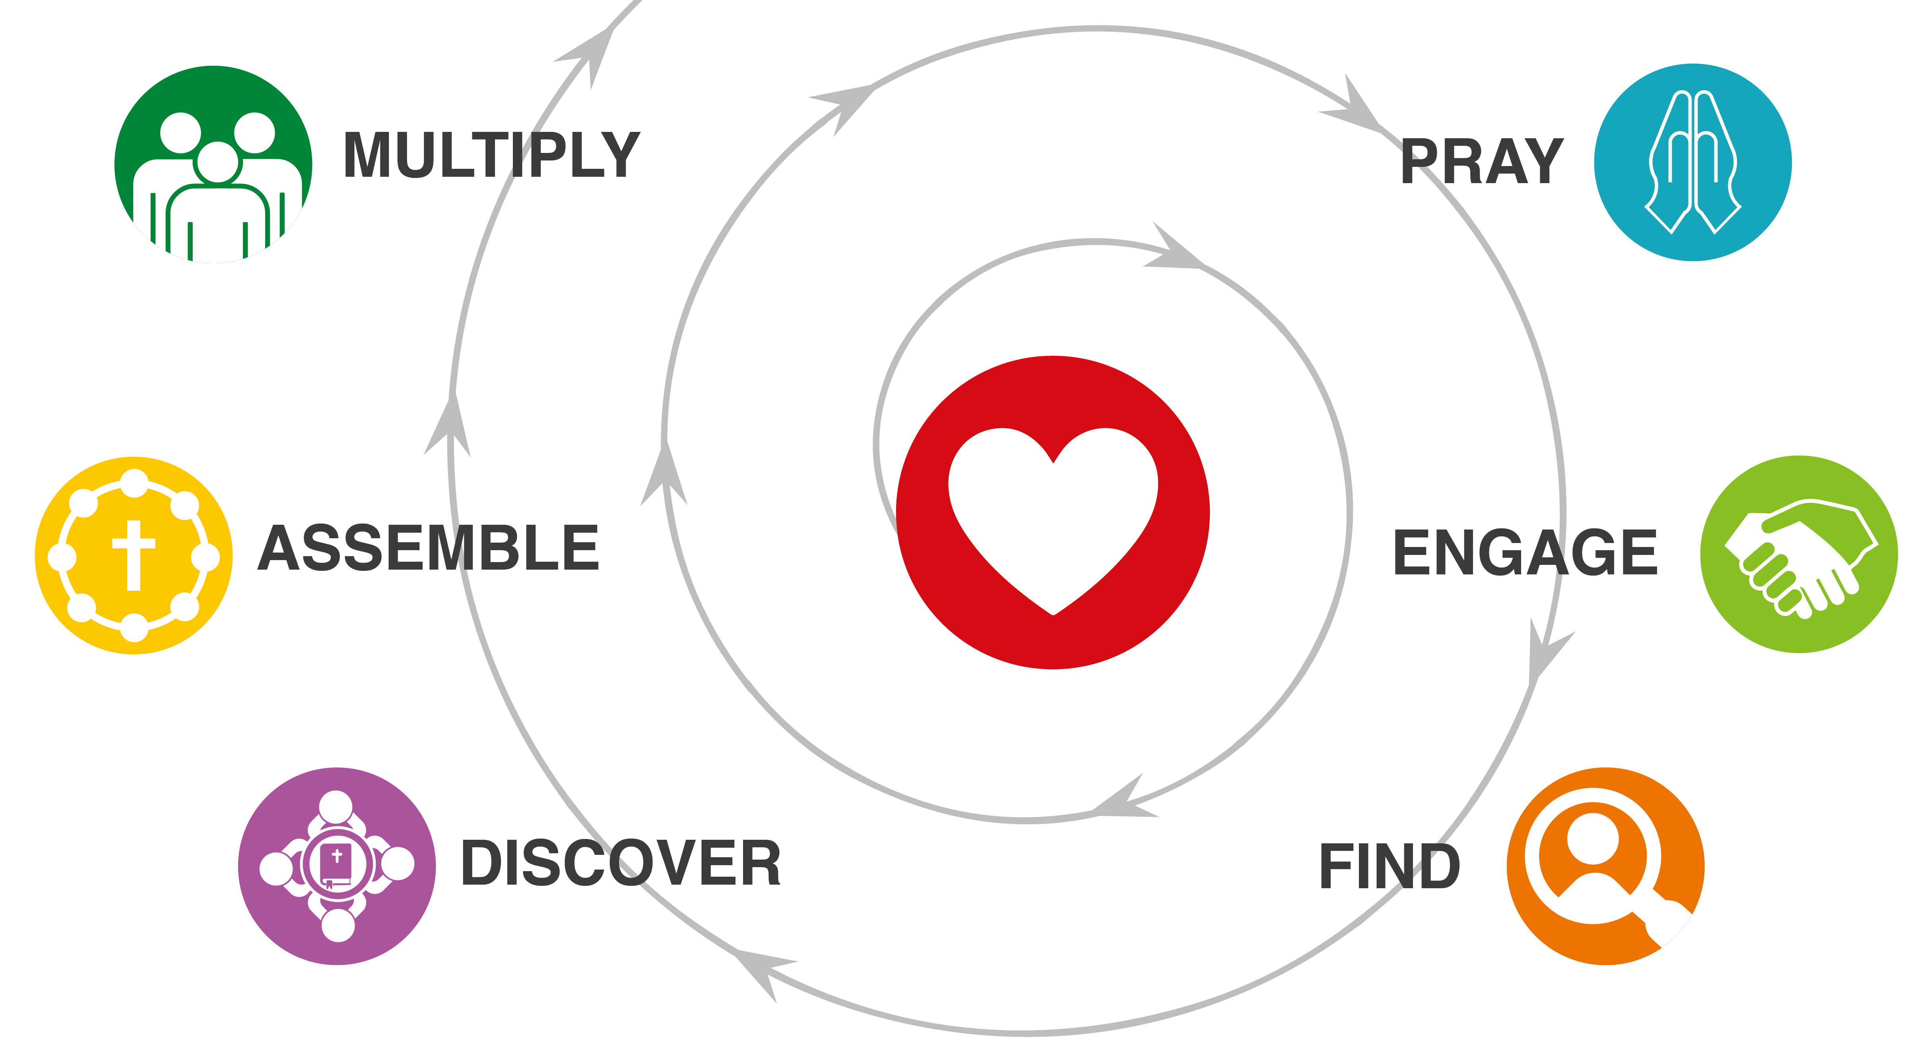
GOD’S HEART & THE HABITS OF A MULTIPLYING DISCIPLE
All the habits are rooted in God’s heart.

The habits are not a method. They are a lifestyle.

There is a logical order to teach them in. But we are growing in all of them continually.

Our journey takes time…

Mindset >> Momentum >> Movement

What does perseverance look like?

YOUR ASSIGNMENT
- Homework: Do 3 Column Study on John 15:1-8
- Write out your answers to these questions:
  - Who do you feel called to reach? (It’s okay if you do not know yet.)
  - Who are two people who can pray for you as you do this training to learn how to make disciple making disciples?
- Do a prayer walk with one or several other people praying for your community or target area.
- Extra Credit. Read the attached “Brief History of the Disciple Making Movement.”

What does it say?
(Write the text word-for-word.)

What does it mean?
(Write it in my own words.)

What must I do to obey?
(My “I will…” statement.)

With whom will I share?

A BRIEF HISTORY OF THE DISCIPLE MAKING MOVEMENT
Disciple Making Movements spread the gospel by making disciples who learn
to obey the Word of God and quickly make other disciples, who repeat the process.
Over time, this results in many new churches being planted, frequently in regions that were not considered open or appeared hostile to faith in Christ.

The Original Disciple Making Movement
Jesus lived in a world very similar to ours in some ways.
  - Spiritually things looked dead.
  - Paganism permeated society.
  - Political change looked hopeless.
But Jesus brought a new kingdom and empowered ordinary people to spread it far and wide.

One Historical Disciple Making Movement
In the 18th century John Wesley lived in a day very much like our own.
  - The established church, the Anglican state church, looked dead.
  - There was rampant alcoholism and family breakdown.
  - The people were experiencing a time of rapid change and confusion, the industrial revolution.

Wesley was passionate to reach his world, so he kept experimenting with how to best do it. In time he developed simple, reproducible methods to empower ordinary men and women to make disciples who make disciples. His methods become known as “Methodism,” and the Wesleyan movement spread around the world impacting hundreds of millions of people. It grew rapidly for almost two centuries, until its leaders felt that it was time to use more traditional church patterns and academic training systems. Even today, there are more Methodist Churches in the United States than there are post offices!

Today’s Move of God
The Disciple Making Movement sweeping the world today had an unusual beginning. In 1985 Keith Parks, the president of the Foreign Mission Board of the Southern Baptist Church, asked the renowned missions researcher David Barrett, how he felt like their agency was doing in their thrust to reach everyone in the world with the gospel before the year 2000. David Garrison tells the story:

Barrett’s response was sweet and sour. “The Foreign Mission Board is doing far better than most Great Commission agencies,” he said “but they will never reach their goal if they continue their current course of action.” Parks was intrigued. Barrett went on to explain that, despite record numbers of new missionaries, Southern Baptists were not even touching a huge sector of the world’s population that Barrett referred to as “World A.”

Barrett went on to describe World A in the context of a tri-partite world. “Viewed from the vantage point of the Great Commission,” he said, “the earth can be broken into one of three worlds.” World C was the portion of the world that professed the Christian religion; just over 30%. World B was the portion of the planet that might be called evangelized, in that it had access to the gospel (through missionaries, Scriptures, scattered churches, etc.), but had not yet accepted the Christian faith as its own. World A was that portion of the world’s population without Christians or a viable Christian witness. Despite Southern Baptist and other evangelical agencies sending sizable numbers of missionaries to foreign fields, virtually none of these were going to World A.

“World A is hostile to residential missionaries,” Barrett explained. Its governments and societies are either Communist or atheist, or Islamic or simply anti-Western.” These factors conspired to keep nearly 1.3 billion lost and unevangelized souls beyond the reach of the gospel. If the Church was going to fulfill its great commission, it would have to find innovative ways to penetrate these untouched corners of the world. (International Journal of Frontier Missions, Fall 2004, p. 118)

This interaction spurred a team of passionate and innovative pioneers within this mission board to discover new methods to penetrate what would later be termed the “10-40 Window,” the swath of the world roughly between 10° and 40° north of the equator that is untouched by the good news of Jesus. Today that portion of the world represents 2/3rds of the world’s population and 82% of the world’s poor. One of those innovators that was spurred to new thinking and action was a missionary named David Watson.

David Watson, who had been a successful church planter in the United States and Malaysia, was sent with his wife Jan to reach the world’s largest unreached people group in the world at that time, the Bhojpuri of Northern India, a group that many missionaries had tried to penetrate, but there had been very little results. Watson set out using traditional church planting methods. He trained Indian leaders to evangelize and start churches, but over a period of 18 months six of these national leaders were killed by angry Hindus, and the Watsons were expelled from the country.

Frustrated and defeated, David prayed and argued with God. He did not want to return to India, but he felt that God wanted him to return. He sensed the Lord say that the problem was rooted in his methods and not the Bhojpuri people. So, over a period of several months, he read through the Bible ten times searching for better, more biblical methods. Gleaning insights from the Bible and fellow innovators, new patterns coalesced in his mind.

He also thought that he could not return to India since he had been expelled, but the mission board encouraged him to try. So, using a new passport, he reapplied for a visa and got one.

Watson together with a passionate Indian pastor named Victor John began to experiment and apply Jesus’ disciple-making methods. At first, they saw very little results. Because of the time required to truly make disciples that make disciples (ex., look at the Gospels!), Watson had a slow start and was at first thought to be lazy by some mission leaders above him. But things took off in time and eventually hundreds, and then thousands, and eventually millions of people were reached.

Since then, the Disciple Making Movement has been spreading throughout the world and there are currently over 1,000 documented movements taking place. (Something is considered a movement if over 100 churches have been planted with at least four generations of churches.)

